Loan Analysis Report
Hannah Mencer

Introduction
The goal of this project was to analyze the relationship between debt-to-income ratio (DTI) and loan default status. Knowing that factors that go into someone defaulting on a loan can help loan providers determine whether to grant a loan. One often important factor in determining if someone gets a loan is how much debt they currently have compared to their income which is also known as their debt-to-income ratio. This study aims to analyze DTIs and resulting outcomes of the associated loan (default or no default) to see if there is a relationship between a borrower’s DTI and their probability of defaulting.
Data
The data used in this study comes from Lending Club which is a platform that provides users with the ability to grant and request loans. For this study, only data from 2018 was used, and there were 56,154 observations used. The dataset consists of multiple variables but was reduced two variables for this study: debt-to-income ratio (DTI) and default status. Default status is recorded as either ‘Default’ or ‘No Default’. Within the DTI column, there were 6 values that were recorded at 999.00. These values were removed because Lending Club uses 999.00 as a placeholder code to indicate missing or invalid DTI information and not an actual DTI value.
Research Questions
There were three research questions explored in this study. The first: Is there a difference in DTI for borrowers who defaulted on their loan versus those who did not default on their loan? The second: If we categorize DTI as low, medium, and high, is there an association between the groups? The third: Is there a relationship between DTI and loan default status?
Methods
To answer the first question a Wilcoxon Rank-Sum Test was used to test the null hypothesis that borrowers who did not default and those who did have identical continuous distributions. This test allows us to see if there is a difference between the groups of defaulting versus non defaulting borrowers.
For the second question, a Chi-Square test of Independence was used to test the null hypothesis that whether a borrower defaults or not is independent of DTI level. If the test rejects the null, then we have evidence that there is an association between the groups.
The third question was answered through fitting a logistic regression model using DTI as the predictor variable and default status as the response variable. An ANOVA test was also done to test whether the slope of the logistic regression was equal to zero or not. Having a slope equal to zero indicates that DTI has no effect on default status.
Results
Assumptions
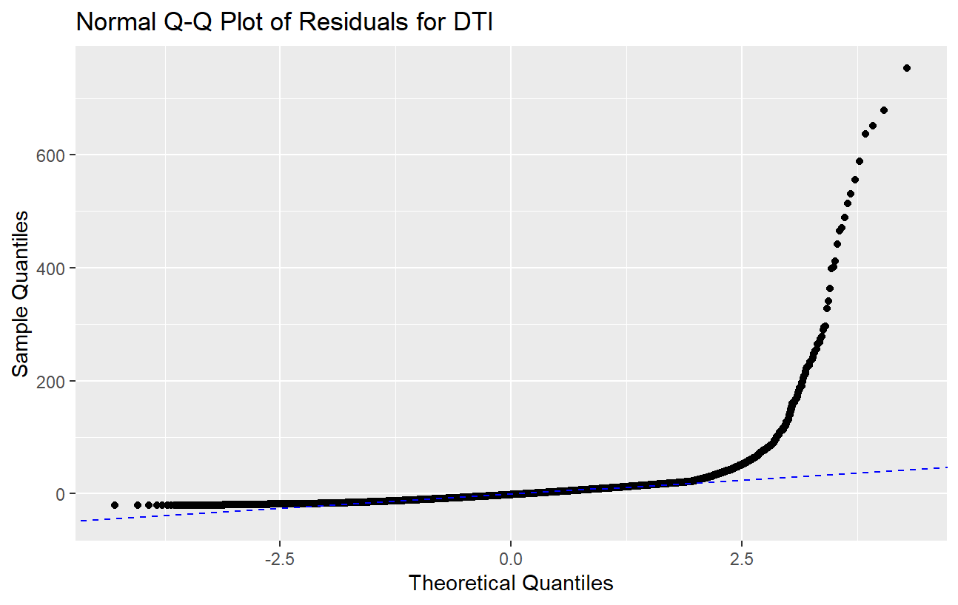
Figure 1
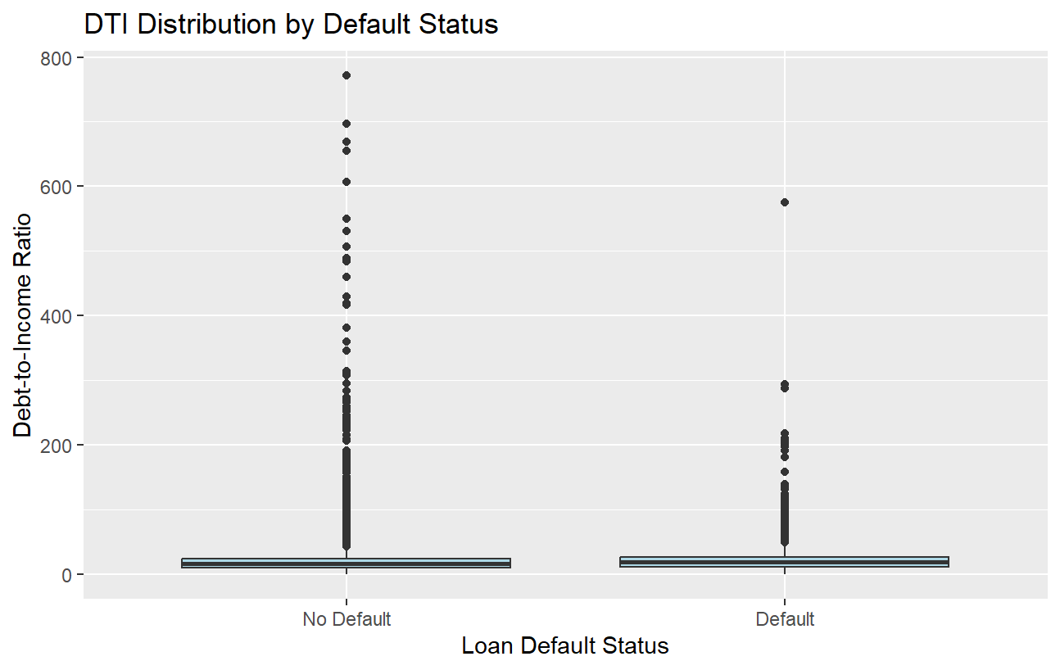
Figure 2
Fig 1. shows that the data is heavily skewed and therefore violating the normality assumption. Additionally, Fig. 2. shows evidence of unequal variances between the two loan status groups thus violating the equal variances assumption. However, independence can be assumed as one borrower’s loan status does not affect another’s. Additionally, the experimental unit as well as the observational unit is the borrower, so independence can be assumed.
Research Question 1
Originally, a two-sample t-test was considered to test the difference in means between groups. Evaluation of the normality and equal variance assumptions showed that they were violated, so a Wilcoxon Rank-Sum Test was used instead as it is robust to outliers and has fewer assumptions. The assumption of independence is met for the reasons stated previously. The Wilcoxon Rank-Sum test yielded the following results:
W | p-value
190705177 | <.0001
With a p-value of <.0001 for the Wilcoxon Rank-Sum test there is strong evidence that one of the populations tends to yield higher values than the other population. This suggests that the medians of the two populations are not equal.
Research Question 2
For the Chi-Square test of Independence, the assumption of independence is reasonable for the same reasons as stated above. An additional column was created in the data to categorize DTI into three levels: low (<36), medium (36-45), and high (>45). A contingency table was constructed with the following results:
DTI Level | No Default | Default | Total
High DTI | 851 | 231 | 1082
Medium DTI | 1342 | 389 | 1731
Low DTI | 45115 | 8225 | 53340
Total | 47308 | 8845 | 56153
From the table we can see that all the sample sizes are greater than 5, so a Chi-Square test is reasonable. The test resulted in a χ² = 88.891 and a p-value of less than 0.0001. With a p-value of <0.0001 there is strong evidence that a borrower’s DTI level is not independent of whether they will default on their loan or not. This suggests that there may be a relationship between DTI and whether a given borrower will default or not.
Research Question 3
For logistic regression, the assumption of independence is reasonable for the same reasons as stated above. After fitting the model, the results were as follows:
Coefficients | Estimate | Std. Error | z-value | Pr(>|z|)
(Intercept) | -1.776 | 0.017 | -104.945 | <0.0001
DTI | 0.005 | .001 | 8.156 | <0.0001
Fitted model: logit(P[default]) = -1.776+0.005(DTI)
Results of the ANOVA test H₀: β1=0:
 | Df | Deviance | Resid. Df | Resid. Dev | Pr(>Chi)
NULL |  |  | 56153 | 48913
DTI | 1 | 69.441 | 56152 | 48843 | <0.0001
Percent Change: 0.00524
Confidence Interval for β1 Percent Change: (0.004, 0.007)
With a p-value of <0.001 for the ANOVA test there is evidence of a relationship between DTI and whether a borrower will default on their loan. A one-unit increase of DTI is associated with a 0.524% increase in the predicted odds of defaulting on a loan. This is consistent with the 95% confidence interval which shows a one-unit increase in DTI being associated with an increase of between 0.4% and 0.7% odds of defaulting.
Conclusions
This analysis examined whether a borrower’s debt-to-income ratio (DTI) is related to loan default status using Lending Club data from 2018. Across all three research questions, the results consistently indicated that DTI is associated with default outcomes.
First, borrowers who defaulted had significantly different DTI values compared to those who did not default, as shown by the Wilcoxon Rank-Sum Test. This suggests that the distribution of DTI differs between the two groups. Second, when DTI was categorized into low, medium, and high levels, the Chi-Square Test of Independence showed a significant association between DTI category and default status. Finally, logistic regression demonstrated that continuous DTI is a statistically significant predictor of default status. Although the effect size is modest, the relationship is consistent and supported by a narrow confidence interval. This suggests that while DTI alone does not fully explain default behavior, it contributes measurable predictive value.
There are, however, several limitations to consider. This model used only one predictor, and loan default is influenced by many additional factors such as credit score, loan grade, employment history, and income stability. Including more variables would likely improve predictive accuracy. Additionally, the data comes from a single lending platform and a single year, which may limit generalizability.
Future analyses could incorporate multiple predictors, explore nonlinear relationships, or compare model performance across different loan types or years. Despite these limitations, the results of this study indicate that DTI is a meaningful factor in understanding and predicting loan default behavior.

